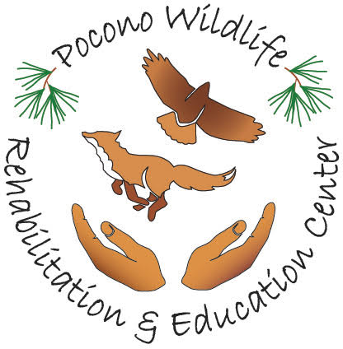
Pocono Wildlife Rehabilitation and
Education Center

1161 Cherry Drive, Stroudsburg PA 18360
www.poconowildlife.org poconowildlife@gmail.com
570-402-0223

Volunteer Agreement

I understand it is a privilege to work with wild animals; and it also entails responsibilities. A PWRC volunteer shall always be compassionate in dealing with the wildlife in their care. While the animals' safety is important, a volunteer must always consider his/her own safety also
.
AS A VOLUNTEER I WILL:
• Show up for my scheduled shift or give at least 24 hours notice via telephone that you will be unable to be at the center on your scheduled day. Two failures to appear without notification will result in removal from the volunteer program.
• Wear the proper gloves and/or protective gear for handling each species as recommended by PWRC or any State and Federal regulations. Gloves and goggles are provided at the facility. • Follow all steps and precautions to prevent escape of an animal, injury to an animal or injury to myself and other volunteers. • Notify Kathy or Eric IMMEDIATELY if I am bitten or scratched by any animal and the skin is broken or any injury occurs while volunteering.
• Notify a supervisor IMMEDIATELY if an animal is injured, escapes or condition is or appears to be otherwise threatened or in distress, at any time.
• Maintain all standards of cleanliness and personal hygiene for the protection of both myself and the animals.
• NOT handle any RVS (rabies vector species - raccoons, skunks, fox, coyotes, bats and groundhogs) without obtaining PWRC RVS CERTIFICATION and providing proof of rabies immunity. Proof of immunity includes pre- and/or post-exposure rabies vaccination documentation or a current blood titer showing adequate protection. Volunteers must have a copy of their vaccines and/or titer in their file. Titers must be rechecked annually. • Follow the care and feeding instructions given to me by PWRC.
• UNDER NO CIRCUMSTANCE will a volunteer bring a visitor, family or guest with them to the center without prior permission. ONLY approved volunteers will be permitted on the premises.
• GNOCHING, CODDLING, OR BABYING REHAB ANIMALS IS STRICTLY PROHIBITED!!!! Human imprinting of a wild animal means its death! There are no warnings with this rule. This is an immediate expulsion from PWRC.
• Not leave the center until ALL assigned tasks are complete. This includes but not limited to: scrubbing all cages, changing all paper, making sure all animals are fed and have fresh water, dishes washed, garbage removed and floor swept. Remember there will be volunteers the following day. Please leave the center how you would like to find it.
• Become familiar with the organization’s mission statement, philosophy policy and procedures

It is important to realize that a volunteer will be exposed to many zoonotic diseases (those transmissible from animals to humans). While ordinary common sense and good hygiene will prevent infection, I understand that it is important to tell my doctor that I work with wildlife on a regular basis. By signing below, I agree with the terms and conditions of volunteering at PWRC.

Volunteer signature:__________________________________________________ Date: ________________

PWRC Representative ____________________________________________________________________ *Policies and rules are subject to change without prior notice

